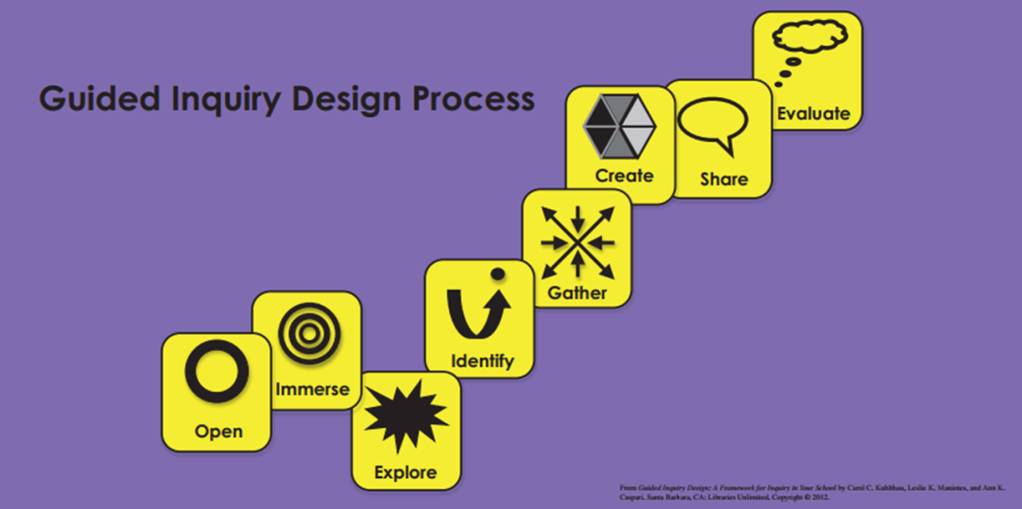

THE GUIDED INQUIRY DESIGN PROCESS
Devised by Carol C. Kuhlthau, Leslie K. Maniotes and Ann K. Caspari

This process is designed for students at all levels, it enables students to learn how to learn and understand one’s own learning process rather than the traditional methods of learning content in isolation.
- OPEN: Invitation to inquiry; Open minds; Stimulate curiosity
- This first phase is the beginning of the inquiry process.
- It is designed to catch the students’ attention, to get them thinking, and help them make connections with the world outside the school.
- The main goal is to open students’ minds and stimulate their curiosity
- To think about the overall content of the inquiry and to connect with what they already know from their experience and personal knowledge.
- To think about ideas and themes, pose questions and problems, and highlight concepts related to the subject.

- IMMERSE: Build background knowledge; Connect to content; Discover interesting ideas
- This phase involves the student building background knowledge, connect with content and discover interesting ideas to explore further.
- Students think about what they already know, reflect on ideas that seem interesting and determine what they want to know more about.

- EXPLORE: Explore interesting ideas; Look around; Dip in
- In this phase, students browse through various sources of information to explore interesting ideas and prepare to develop their inquiry question.
- Students explore ideas not gather facts.
- Students survey a wide range of sources, read when they find something interesting and then reflect on questions that begin to shape their inquiry
- Ideas of sources include: Books in the library; Current materials, magazines, online newspapers, news clips, videos; Databases; Encyclopedia articles, both print and web-based, for example: world book, Wikipedia; Maps and atlases, both print and web-based, for example: Google Earth; Web sites; Videos, podcasts, T.E.D talks, virtual tours, You Tube; Images, art, photos, posters, both print and web-based, for example, those from the Smithsonian Institute, Art Gallery of NSW, National Art Gallery; Australian War Museum, letters, diaries, music scores, documents, music recordings; Refer to the school’s Library website for other ideas
- Questions to ask when browsing:
- “What do I want to know more about?”
- “Which sources do I want to spend a little more time with?”
- “Which sources do I want to dip into further?”
- “Why do I think it might be a useful source?”
- “How does it provide variety and multiple perspectives to the work?”

- IDENTIFY: Pause and ponder; Identify inquiry question; Decide direction
- The main task of this Identify phase is for students to construct an inquiry question from the interesting ideas, pressing problems and themes they have explored in various sources of information
- Students will articulate a meaningful inquiry question that will frame the rest of the inquiry
- Students brainstorm using a mind map to organize and cluster their ideas together
- Introduce Criteria for Deciding questions to determine the focus research question:
- “What am I trying to achieve?”
- “How interested am I in this idea?”
- “How much time do I have?”
- “What information and resources are available?”

- GATHER: Gather important information; Go broad; Go deep
- The main task of the Gather phase is for students to choose what is personally meaningful and compelling about their inquiry question in the information sources they find
- Students “Go broad” to find a wide range of sources that are useful for understanding their inquiry question.
- Students also “Go deep” and choose a core of the most useful sources to find connections and gain personal understanding
- GOING DEEP: Students read through sources found in the Explore stage and go deep by thinking through the following questions:
- “What do I think is most important in this passage?”
- “How would I summarise what is most important?”
- What might I quote directly?”
- “What ideas, connections and interpretations does it raise for me?”

- CREATE: Reflect on learning; Go beyond facts to make meaning; Create to communicate
- After students have gathered enough information to construct their own understandings, they are ready to organize their learning into a creative presentation during the Create phase
- Students can clarify exactly what they will use in their published version of their inquiry by completing a chart that starts with the Inquiry question, followed by the most important ideas they have learned and where they will want to place their ideas.
- Some questions to ask:
- Do some of your ideas fit together?
- Do some ideas not fit at all?
- Do some ideas seem more important?
- Are you seeing some ideas intersecting? Overlapping? Connecting? Is one theme surfacing?
- Identify what (connections, interpretations) you see by drawing lines, arrows, circles, colours and highlights.
- Be creative in your presentation: you could use Prezi, Issuu, Story Map, Power point, Story bird, etc. Refer to the school’s Library website for ideas

- SHARE: Learn from each other; Share learning; Tell your story
- Share is when students get to share the product they have created
- The student has become an expert on the area of their research and now have the opportunity and responsibility to share their insights and contribute their learning to others
- Students present their research to the group
- After their presentation, the student then includes the following to their share time:
- 5 minutes to share highlights of their learning
- 2 minutes for questions and answers from the group
- I minute for presenter’s final thoughts
- The audience also has a role when observing their peer’s presentation, they write:
- Presenter’s name
- Your name
- Two interesting ideas you have learned
- One question you have

- EVALUATE: Evaluate achievement of learning goals; Reflect on content; Reflect on process
- This is the last phase of the Guided Inquiry process
- Evaluation occurs at the end so that the student can evaluate their achievement of their learning goals
- Students fill in a self-reflection form that includes evaluating the way they have learned; the use of the Inquiry tools and the Inquiry process
- Students think about and respond to these questions:
- What have I learned about the inquiry process?
- What did I do well that I would repeat in the next inquiry?
- What will I do differently next time?

